“Київський фаховий коледж зв’язку”

Циклова комісія Комп’ютерної інженерії

**ЗВІТ ПО ВИКОНАННЮ**

**ЛАБОРАТОРНОЇ РОБОТИ №7**

з дисципліни: «Операційні системи»

**Тема: «Створення скриптових сценаріїв та визначення апаратної конфігурації системи»**

Виконавли студенти

групи РПЗ-03

Команда: Губенко Є.О.,

Заїка С.В. та Кресан Р.А.

Перевірив викладач

Сушанова В.С.

Київ 2022

**Мета роботи:**

1. Отримання практичних навиків роботи з командною оболонкою Bash.
2. Знайомство знайомство з базовими діями при роботі зі скриптовими сценаріями.

**Матеріальне забезпечення занять**

1. ЕОМ типу IBM PC.
2. ОС сімейства Windows (Windows 7).
3. Віртуальна машина – Virtual Box (Oracle).
4. Операційна система GNU/Linux – CentOS.
5. Сайт мережевої академії Cisco netacad.com та його онлайн курси по Linux

**Завдання для попередньої підготовки**

***Готував матеріал студент Губенко Є.О***

1. Прочитайте короткі теоретичні відомості до лабораторної роботи та зробіть невеликий словник базових англійських термінів з питань призначення команд та їх параметрів.
2. Вивчіть матеріали онлайн-курсу академії Cisco “NDG Linux Essentials”:
   * Chapter 11 - Basic Scripting
   * Chapter 12 - Understanding Computer Hardware
3. Пройдіть тестування у курсі NDG Linux Essentials за такими темами:
   * Chapter 11 Exam
   * Chapter 12 Exam
4. На базі розглянутого матеріалу дайте відповіді на наступні питання:
   1. Охарактеризуйте поняття скриптового сценарію у командній оболонці.

*A shell script is a file that contains a sequence of commands and instructions that are executed sequentially when the script is run. Scripts are typically used to automate repetitive tasks or to run complex processes from multiple commands.*

*All commands supported by the command shell, such as variables, branching, loops, and functions, can be used in a scripted script. Scripts are usually stored in text files with the extension .sh (for the Bash shell on Unix-like systems) or .bat (for the Windows shell).*

*Using scripting can help save time and effort, simplify the process of working with the shell, reduce errors, and provide more consistent and predictable system operation.*

* 1. Яким чином створюються та редагуються скрипти, що треба зробити щоб запустити скрипт?

*To create a script in the command shell, you first need to create a text file with the extension .sh (for Unix-like systems) or .bat (for Windows). In this file, we will record the sequence of commands we want to execute. Next, open the file in a text editor and write down the commands you want to execute, one by one, on a new line. After we have written the script, save the file with the extension .sh or .bat.*

*Після створення скрипту, ми можемо редагувати його в будь-який час, відкриваючи файл у текстовому редакторі та вносячи зміни в послідовність команд.*

*To run the script, we need to have the rights to execute the file. On Unix-like systems, this can be done with the command chmod +x script.sh, where script.sh is the name of the file with our script. After that, we can run the script by entering the command ./script.sh in a command shell.*

*On Windows, a file with the .bat extension can be run simply by double-clicking on it in Windows Explorer. But in the command shell, you can run the file by typing its name without the extension on the command line. For example, if the name of our script is script.bat, we can run it by entering the script command at the command prompt.*

* 1. Які основні компоненти материнської плати ви знаєте?

*A motherboard is one of the main components of a computer that houses a variety of other components. The main components of the motherboard are:*

* ***Socket*** *- is the place on the motherboard where the processor is located. Depending on the type of processor, the socket can be of different sizes and shapes.*
* ***Slots for RAM*** *- are the places on the motherboard where the RAM modules are located. Modern motherboards usually use DDR4 slots.*
* ***Expansion slots*** *- are places on the motherboard where you can connect various expansion cards, such as sound cards, network cards, video cards, etc. The most common types of expansion slots are PCIe and PCI.*
* ***Input and output controllers*** *- are components that manage a variety of I/O interfaces, such as USB, SATA, Ethernet, HDMI, and others.*
* ***Chipset*** *- is a component that provides communication between other components on the motherboard, controls the data transfer rate and other system parameters.*
* ***Bios*** *- is a software component that initializes and configures hardware components at computer startup and stores the basic system settings.*

*These components may vary depending on the specific motherboard model and its purpose.*

* 1. Коротко охарактеризуйте для яких пристроїв оперують поняттями MBR та GPT?

*The MBR (Master Boot Record) and GPT (GUID Partition Table) are two different data structures used to organize disk space on external and internal hard drives.*

*The MBR is used for older operating systems, such as Windows XP, which can be installed on hard disks up to 2 TB in size. The MBR can contain up to four primary disk partitions or three primary partitions and one extended partition containing multiple logical partitions.*

*GPT is a more modern standard and is commonly used on hard drives larger than 2 TB. It can contain up to 128 partitions, so it is more flexible and efficient. GPT also has a more robust data protection system and supports more file system formats, such as NTFS, FAT32, exFAT, and others.*

*Both standards are used to organize disk space on external and internal hard drives, as well as on floppy disks and other similar storage devices.*

* 1. В чому суть операції монтування, для чого вона потрібна?

*The mount operation is the process of attaching (connecting) a file system to the file hierarchy of the operating system. After mounting, the file system becomes available for reading and writing in the operating system.*

*Mounting is necessary because most operating systems present disks and storage devices as file systems that are located in separate partitions. If the file system is not mounted, it will not be available for use. For example, when you connect an external hard disk to your computer, you must first mount it so that the operating system can read and write files to the disk.*

*The mounting operation can be performed either automatically, when the operating system recognizes the connected device and mounts it automatically, or manually, when the user specifies the directory where the device with the file system should be mounted.*

1. Підготувати в електронному вигляді початковий варіант звіту:

* Титульний аркуш, тема та мета роботи
* Словник термінів
* Відповіді на п.4.1 та п.4.5 з завдань для попередньої підготовки

**Хід роботи**

1. Початкова робота в CLI-режимі в Linux ОС сімейства Linux:
   * Запустіть віртуальну машину VirtualBox, оберіть CentOS та запустіть її. Виконайте вхід в систему під користувачем: CentOS, пароль для входу: reverse (якщо виконуєте ЛР у 401 ауд.) та запустіть термінал.
   * Запустіть віртуальну машину Ubuntu_PC (якщо виконуєте завдання ЛР через академію netacad)
   * Запустіть свою операційну систему сімейства Linux (якщо працюєте на власному ПК та її встановили) та запустіть термінал.

***Готував матеріал студент Заїка С. В.***

1. Опрацюйте всі приклади команд, що представлені у лабораторних роботах курсу NDG Linux Essentials - Lab 11: Basic Scripting та Lab 12: Understanding Computer Hardware. Створіть таблицю для опису цих команд***

|  |  |
| --- | --- |
| **Назва команди** | **Її призначення та функціональність** |
| vi myfile | The vi myfile command opens the Vim (Vi Improved) text editor to edit the file named "myfile". Vim is a powerful command-line text editing tool that provides many useful features, such as syntax highlighting, auto-completion, and more. |
| dw | The dw command is short for "delete word" and is used in the Vim text editor to delete the word on which the cursor is positioned. Vim defines a word as a sequence of characters separated by spaces, tabs, or newlines. |
| xxxx | The xxxx command is not a standard command in text editors or in the operating system. Please clarify which context or program you are referring to so that I can provide a useful answer. |
| :%s/text//g | The :%s/text//g command performs a search and replace in the Vim text editor throughout a file. Replace consists of removing all occurrences of the substring text followed by a space (or other delimiter) in the entire file. The % symbol indicates that the search and replacement will take place in the entire file, s indicates the replacement command, / is the search expression separator, // is the replacement expression separator, g indicates that you need to replace all occurrences of the string, not just the first one. |
| :x | Will save and close the file. |
| :wq | Will write to file and quit. |
| :wq! | Will write to a read-only file, if possible, and quit. |
| ZZ | Will save and close. Notice that no colon : is used in this case. |
| :q! | Exit without saving changes |
| :e! | Discard changes and reload file |
| :w! | Write to read-only, if possible. |
| lscpu | The lscpu command is used in the Linux operating system to display information about the central processing unit (CPU) on a system. Running the command displays detailed information about the CPU architecture, such as the manufacturer, model, number of cores and threads, clock speed, cache, and other parameters. |
| head -n 20/proc/cpuinfo | The head -n 20 /proc/cpuinfo command is used in the Linux operating system to display the first 20 lines of the /proc/cpuinfo file, which contains information about the central processing unit (CPU) on the system. |
| lspci | The lspci command is used in the Linux operating system to display information about PCI (Peripheral Component Interconnect) devices connected to the computer. Running the command displays a list of all devices connected to the PCI bus, along with their identifiers, manufacturers, and models. |
| lsusb | The lsusb command is used in the Linux operating system to display information about USB devices connected to the computer. Running the command displays a list of all USB devices connected to the system, along with their identifiers, manufacturers, and models. |
| fdisc - l | The fdisk -l command is used in the Linux operating system to display information about disk partitions on the system. Running the command displays a list of all disk devices on the system and their partitions, along with their parameters, such as file system type and partition size. |

***Готував матеріал студент Кресан Руслан***

1. Створіть скриптові сценарії з виводом текстових повідомлень для користувача (продемонструйте скріншоти):
   * **сценарій має виводити привітання до поточного користувача вказуючи поточну дату та інформацію про поточну систему;**

*To create a script, we need to open a text editor, write the necessary commands into it, and save the file with the ".sh" extension.*

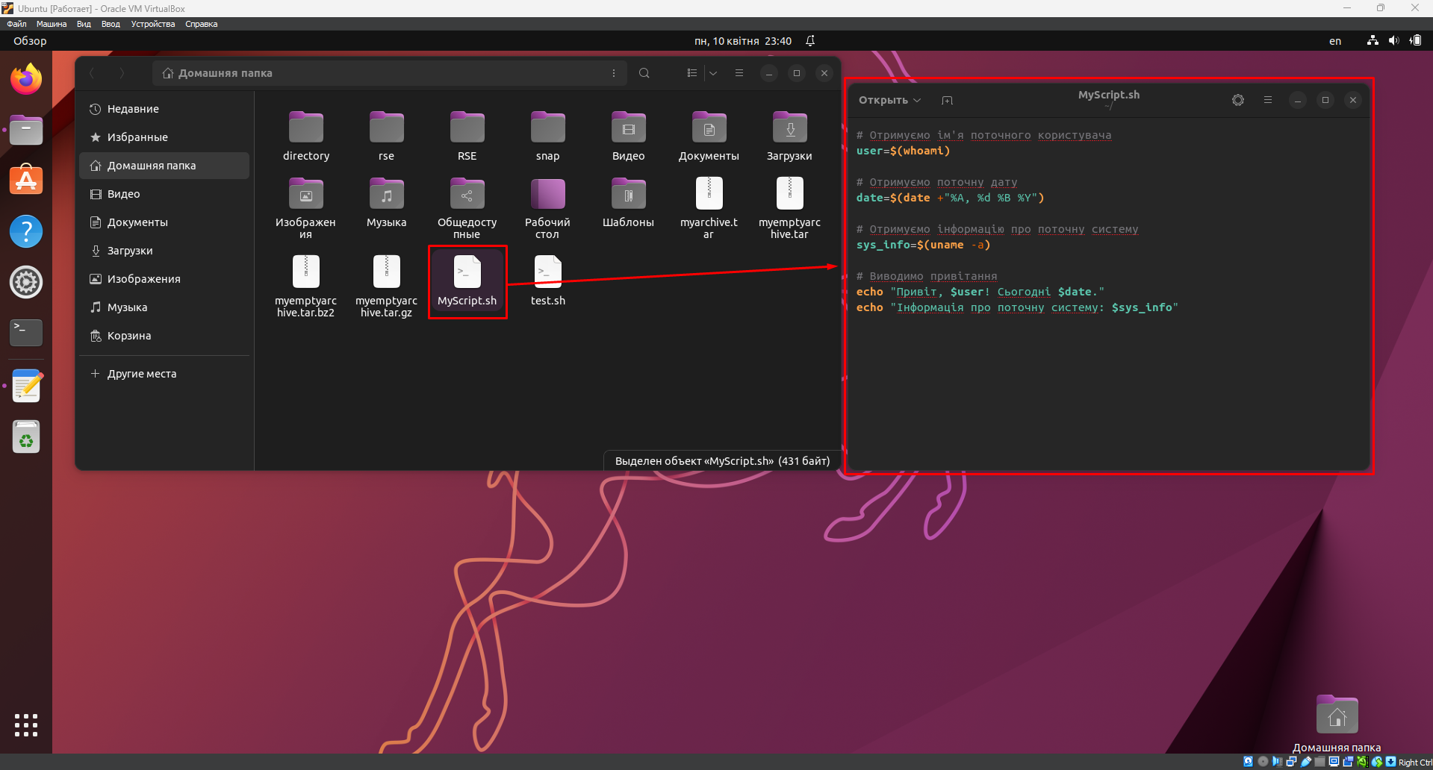

*After that, you need to open a terminal and set the file's permissions using the chmod command.*

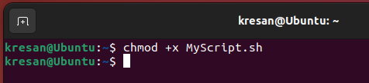

*Next, we can run the script by running the command ./MyScript.sh.*

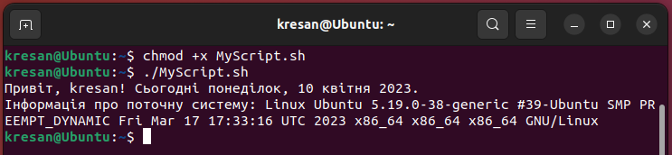

* + **сценарій має виводити інформацію про апаратну конфігурацію поточної системи (використовуйте команди розглянуті в Lab 12).**

*Just like in the previous task, we create a file with the ".sh" extension, enter the necessary commands into it, set the execution right, and run the script.*

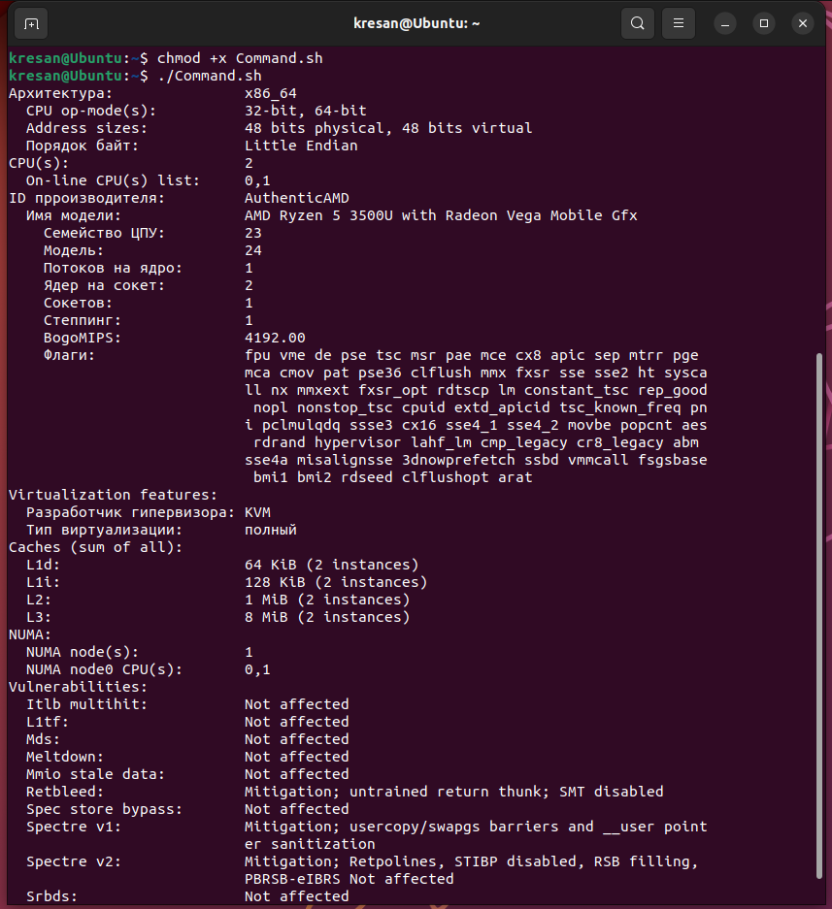

***Готував матеріал студент Губенко Є.О***

**Відповіді на контрольні запитання**

1. Яким чином у скриптах можна опрацьовувати змінні та створювати розгалужені та циклічні сценарії?

*In scripts written in a Linux shell programming language such as Bash, you can manipulate variables and create branching (conditional) and looping (cyclic) scripts. Here are some basic approaches:*

* *Variables: You can create variables in Bash scripts by assigning values to variables. For example:*

*name="John"*

*age=30*

*echo "* *My name is $name and I am $age years."*

* *Branching (conditional) statements: You can use branching statements such as if, elif, and else to perform different actions depending on a condition. For example:*

*age=30*

*if [ $age -gt 18 ]; then*

*echo "* *I am an adult."*

*else*

*echo "* *I am a child."*

*fi*

* *Looping (cyclic) statements: You can use looping constructs such as for, while, and until to execute a block of code multiple times or until a specific condition is met. For example:*

*count=1*

*while [ $count -le 5 ]; do*

*echo "* *Value: $count "*

*count=$((count+1))*

*done*

1. В чому відмінність між командами arch та lscpu?

*The arch and lscpu commands are two different commands that provide different information about the operating system and hardware of the computer.*

*The arch command returns information about the architecture of the operating system on which the process is running, for example, x86, x86_64, arm, arm64, etc. To get this information, just enter the arch command in the terminal, which will return the result as a text string with the name of the architecture.*

*For example, running the arch command on a computer with the x86_64 architecture will return the following result: x86_64*

*The lscpu command, on the other hand, returns detailed information about the hardware, such as the number of processors, their model, number of cores, cache size, and other details of the system's hardware configuration. The result of the lscpu command is also returned as a text string.*

*For example, running the lscpu command on a computer with two Intel Xeon E5-2697 processors will return the following result:*

***Architecture: x86_64***

***CPU op-mode(s): 32-bit, 64-bit***

***Byte Order: Little Endian***

***CPU(s): 48***

***On-line CPU(s) list: 0-47***

***Thread(s) per core: 2***

***Core(s) per socket: 12***

***Socket(s): 2***

***NUMA node(s): 2***

***Vendor ID: GenuineIntel***

***CPU family: 6***

***Model: 63***

***Model name: Intel(R) Xeon(R) CPU E5-2697 v3 @ 2.60GHz***

***Stepping: 2***

***CPU MHz: 2594.251***

***BogoMIPS: 5192.50***

***Virtualization: VT-x***

***L1d cache: 32K***

***L1i cache: 32K***

***L2 cache: 256K***

***L3 cache: 35840K***

***NUMA node0 CPU(s): 0-11,24-35***

***NUMA node1 CPU(s): 12-23,36-47***

*So, the main difference between the arch and lscpu commands is that the first command returns information about the operating system architecture, while the second returns information about the computer hardware. Both commands are useful in determining system parameters and can be used to diagnose, configure, and manage a computer.*

1. Якою командою можна отримати інформацію про стан використання RAM поточною системою?

*In most operating systems, the free command is used to get information about the current system's RAM usage.*

*This command shows the total amount of physical and virtual memory used by the system, as well as the amount of free, free for buffering, and free for caching memory. To use the command, open a terminal and type: free*

*If you want to get more detailed information about RAM usage, you can use the top command, which shows information about the processes running on your system, including information about RAM usage. To run the top command, open a terminal and type: top*

*At the top of the top window, you will see general information about the system, including memory usage.*

1. Які команди для перегляду стану підключення периферійних пристроїв можна використати в терміналі?

*To view the connection status of peripherals in the terminal, you can use the following commands:*

* *lsusb: This command shows a list of all USB devices connected to your system. If the device is properly connected and its drivers are installed, you can see detailed information about the device, such as the manufacturer and model ID.*
* *lspci: This command shows a list of all PCI devices connected to your system, such as graphics cards, network adapters, and others. It also shows detailed information about the device, such as its ID, name, and manufacturer.*
* *lsblk: This command shows a list of all the storage on your system, including hard disks, flash drives, and other storage devices. It also shows information about their size and file system type.*
* *dmesg: This command displays the kernel event log, which contains information about connecting and disconnecting peripherals, as well as other events related to their operation.*
* *udevadm: This command allows you to interact with the udev device management system, which is responsible for dynamically creating and deleting device files. It allows you to view information about connected devices, including their identifiers, types, and properties.*

1. Які можливості застунку gparted?

*GParted is a graphical interface for managing disks and partitions in Linux and Windows. It has the following features:*

* *Create, delete, edit, and move partitions on your hard disk.*
* *Move partitions on your hard disk without losing data.*
* *Move free space between partitions.*
* *Format partitions in various file systems, such as NTFS, FAT32, ext4, and many others.*
* *Rename partitions.*
* *View information about the hard disk and partitions, including file system types, partition sizes, and contents.*
* *Work with disks containing different types of partitions, such as MBR and GPT.*
* *Convert MBR to GPT and vice versa.*
* *Clone a disk or partition to create a data backup.*
* *Multiple language support and user-friendly interface.*

*All in all, GParted is a powerful and user-friendly disk and partition management tool for Linux and Windows that allows users to easily and efficiently manage their hard disk data.*

***Готував матеріал студент Заїка С. В.***

**Висновки**

During the laboratory work, we gained practical skills in working with the Bash command shell and got acquainted with the basic actions when working with scripted scenarios.